Project Documentation

1. Project Title | AUTO TICKET CLASSIFICATION USING FLOW DESIGNER
2. Team ID | SWTID-2026-1390
3. Team Leader | S. Pushpavalli – 202400107@sigc.edu
4. Team Member | K. Soundarya – 202400355@sigc.edu
5. Team Member | A. Sivapriya – 202400200@sigc.edu
6. Team Member | R. Sirumbayee – 202400718@sigc.edu

2. Abstract
The project demonstrates an automated ticket-classification workflow using ServiceNow Flow Designer. A custom ticket table is created and configured with the required fields and choice values. Flow Designer is then used to define a trigger, evaluate ticket information, and perform automated actions based on configured conditions. The workflow helps reduce repetitive manual ticket processing and provides a consistent method for handling school IT tickets.
Initial ServiceNow project screen
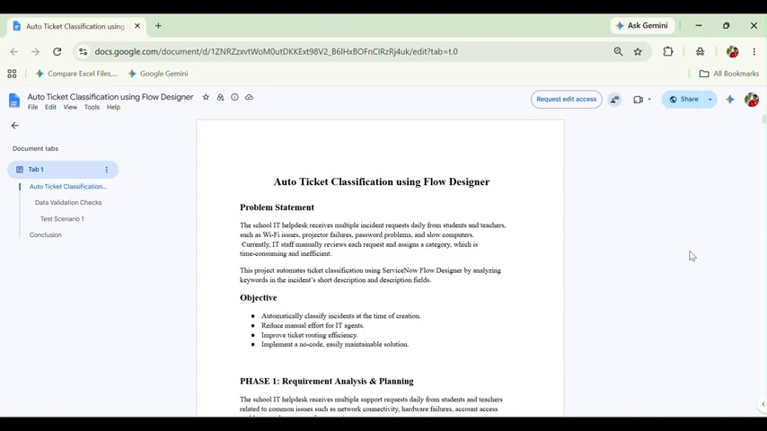

3. Introduction
ServiceNow Flow Designer provides a visual way to automate business processes. In this project, ticket details are captured in a custom table and processed through a flow. The flow uses ticket data to apply the required classification and update logic.

4. Objectives
- Create and configure a custom ticket table.
- Design a ticket form with relevant fields.
- Configure choice values such as ticket State.
- Create an automated flow using Flow Designer.
- Use ticket field values and conditions to drive actions.
- Test the workflow and verify the resulting ticket updates.

5. Step-by-Step Procedure

5.1 Create the Custom Ticket Table
Create a new table in ServiceNow and define the fields needed to store ticket information.

5.2 Configure the Ticket Form
Use Form Design to arrange the ticket fields in a clear and usable layout.

5.3 Configure Choice Values
Add suitable choices for fields such as State, including values required by the workflow.

5.4 Review the Table
Verify the table, fields, and form configuration before creating the automation.

5.5 Create the Flow
Open Flow Designer and create the Auto Ticket Classification flow.

5.6 Configure the Trigger
Select the appropriate ticket table and define the event that starts the flow.

5.7 Add Conditions and Actions
Use ticket fields/data pills to evaluate the record and configure the required actions.

5.8 Test the Flow
Run the flow with a test ticket and verify that the classification/update logic works correctly.

6. Screenshots / Project Evidence
Figure 2: Creating the custom ticket table
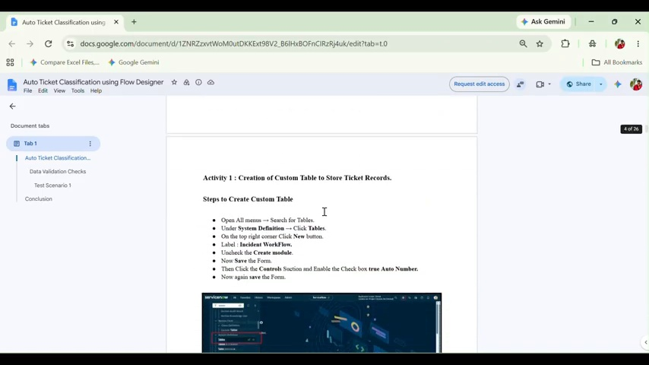
Figure 3: Form Design – adding ticket fields
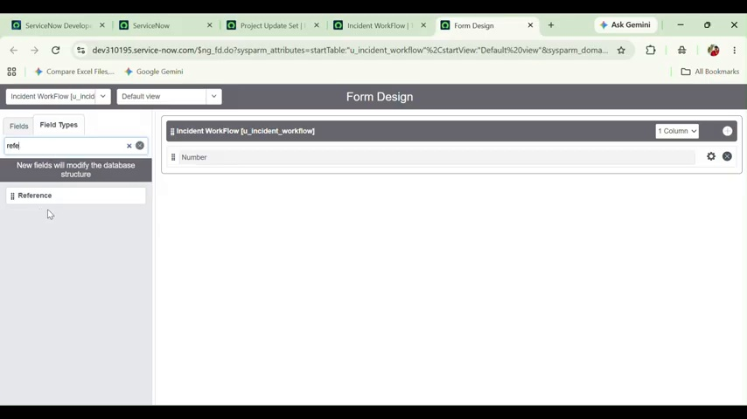
Figure 4: Ticket field configuration
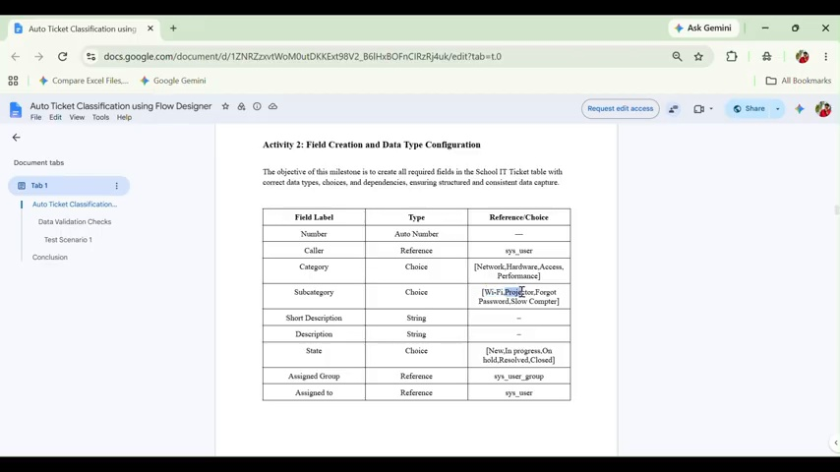
Figure 5: Configuring State choices
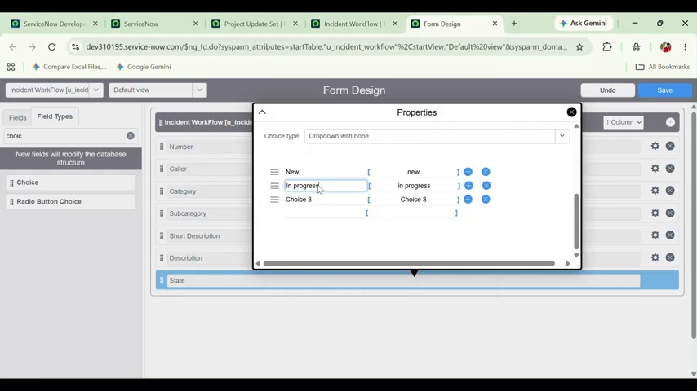
Figure 6: Reviewing the created table
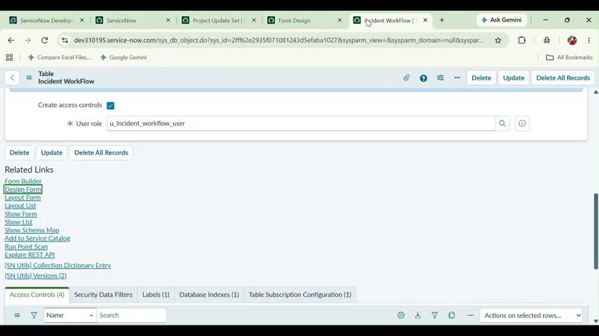
Figure 7: Creating the Flow Designer flow
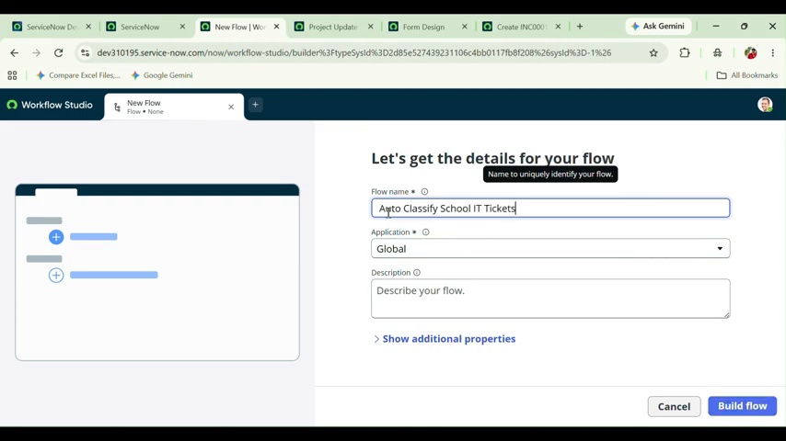
Figure 8: Configuring the flow trigger
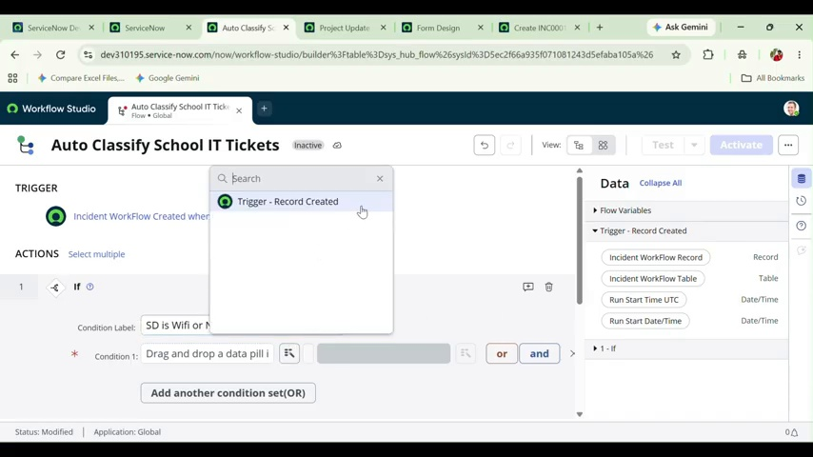
Figure 9: Building flow actions
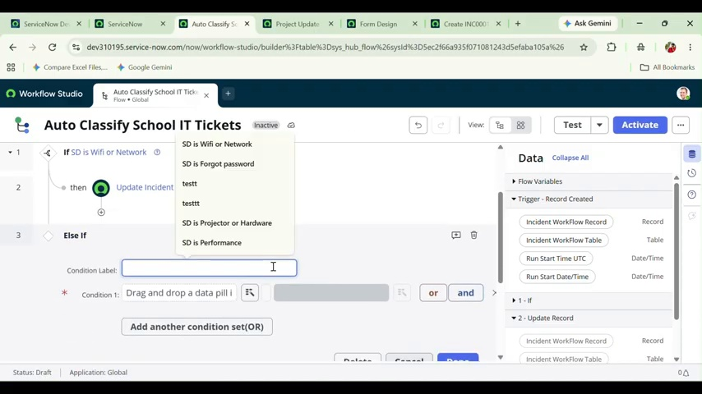
Figure 10: Selecting field values and logic
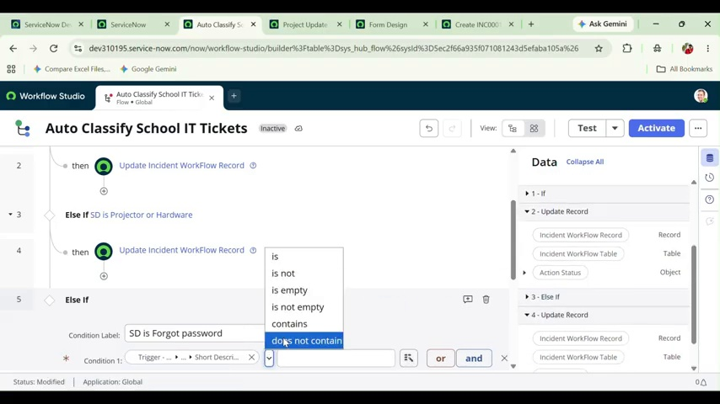
Figure 11: Action properties and completed flow
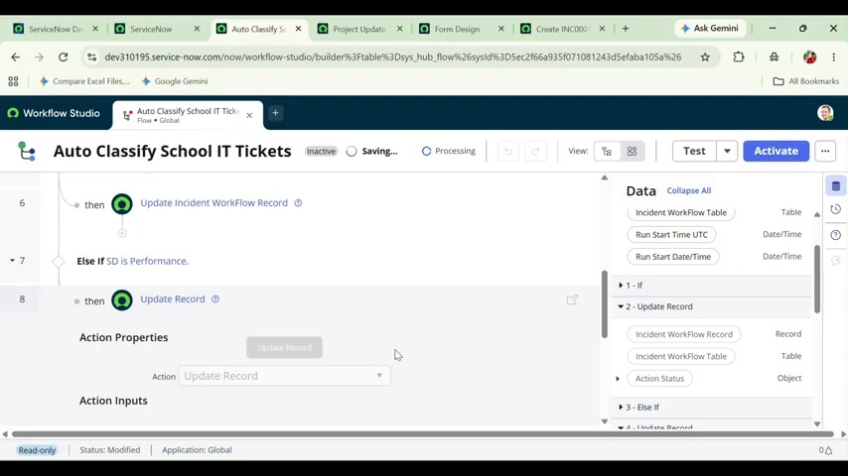

7. Conclusion
The project demonstrates how ServiceNow Flow Designer can be used to automate ticket classification and processing. The custom ticket structure, configured fields, trigger, conditions, and actions work together to reduce manual effort and provide a consistent workflow.

Reference:
Demo video: https://drive.google.com/file/d/1GIYQYe5cAjrQ_H0DPNnbqsgoQXHxuRbo/view?usp=drivesdk
Github link: https://github.com/pushpavalli107

